**Figure 1.** Scoring system used to assess the quality of reported specific tension (ST) values. ST is typically calculated as force divided by physiological cross-sectional area (PCSA) or anatomical cross-sectional area (ACSA) for elbow flexors. Scores are represented by bold text in each box. Each study's methodologies are assessed using each column, and the total score for each study was determined by summing individual scores across columns for Force and PCSA/ACSA. The maximum score that can be obtained is 31.

**Figure 2.** PRISMA flowchart for current literature search.

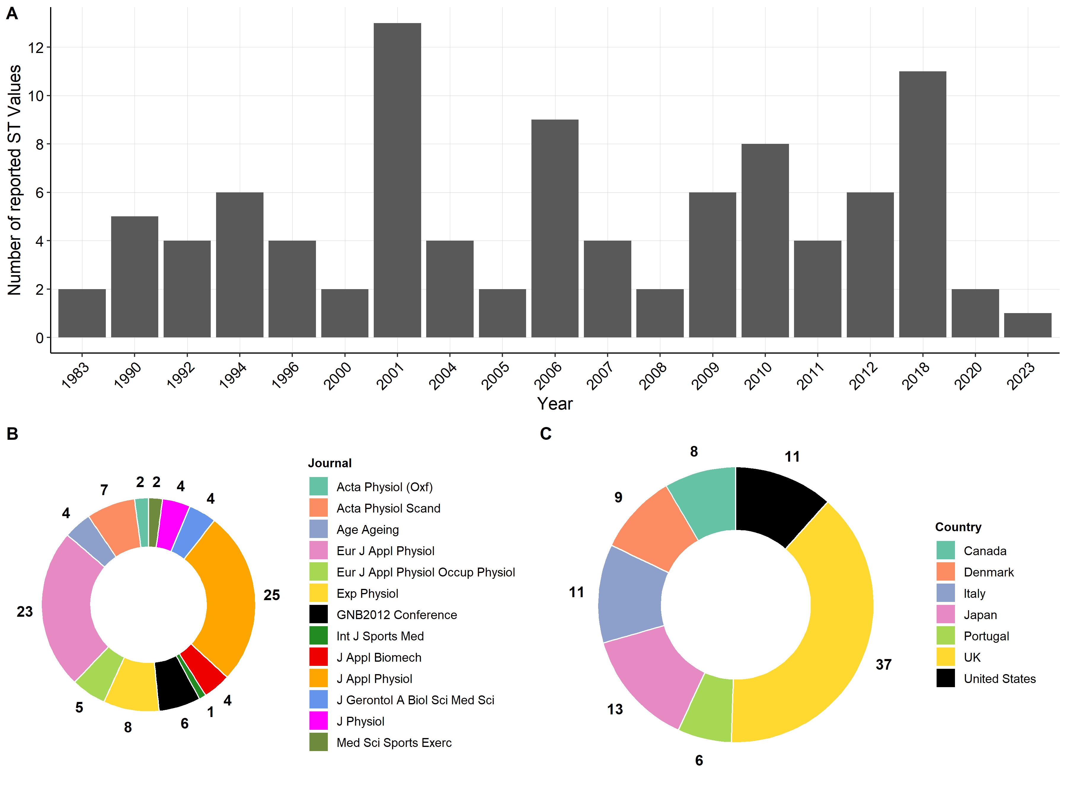

**Figure 3.** Summary of ST values extracted from the included studies (n=29). (A) Distribution of reported ST values by year. (B) Distribution of reported ST value by journal. (C) Distribution of reported ST value by country.

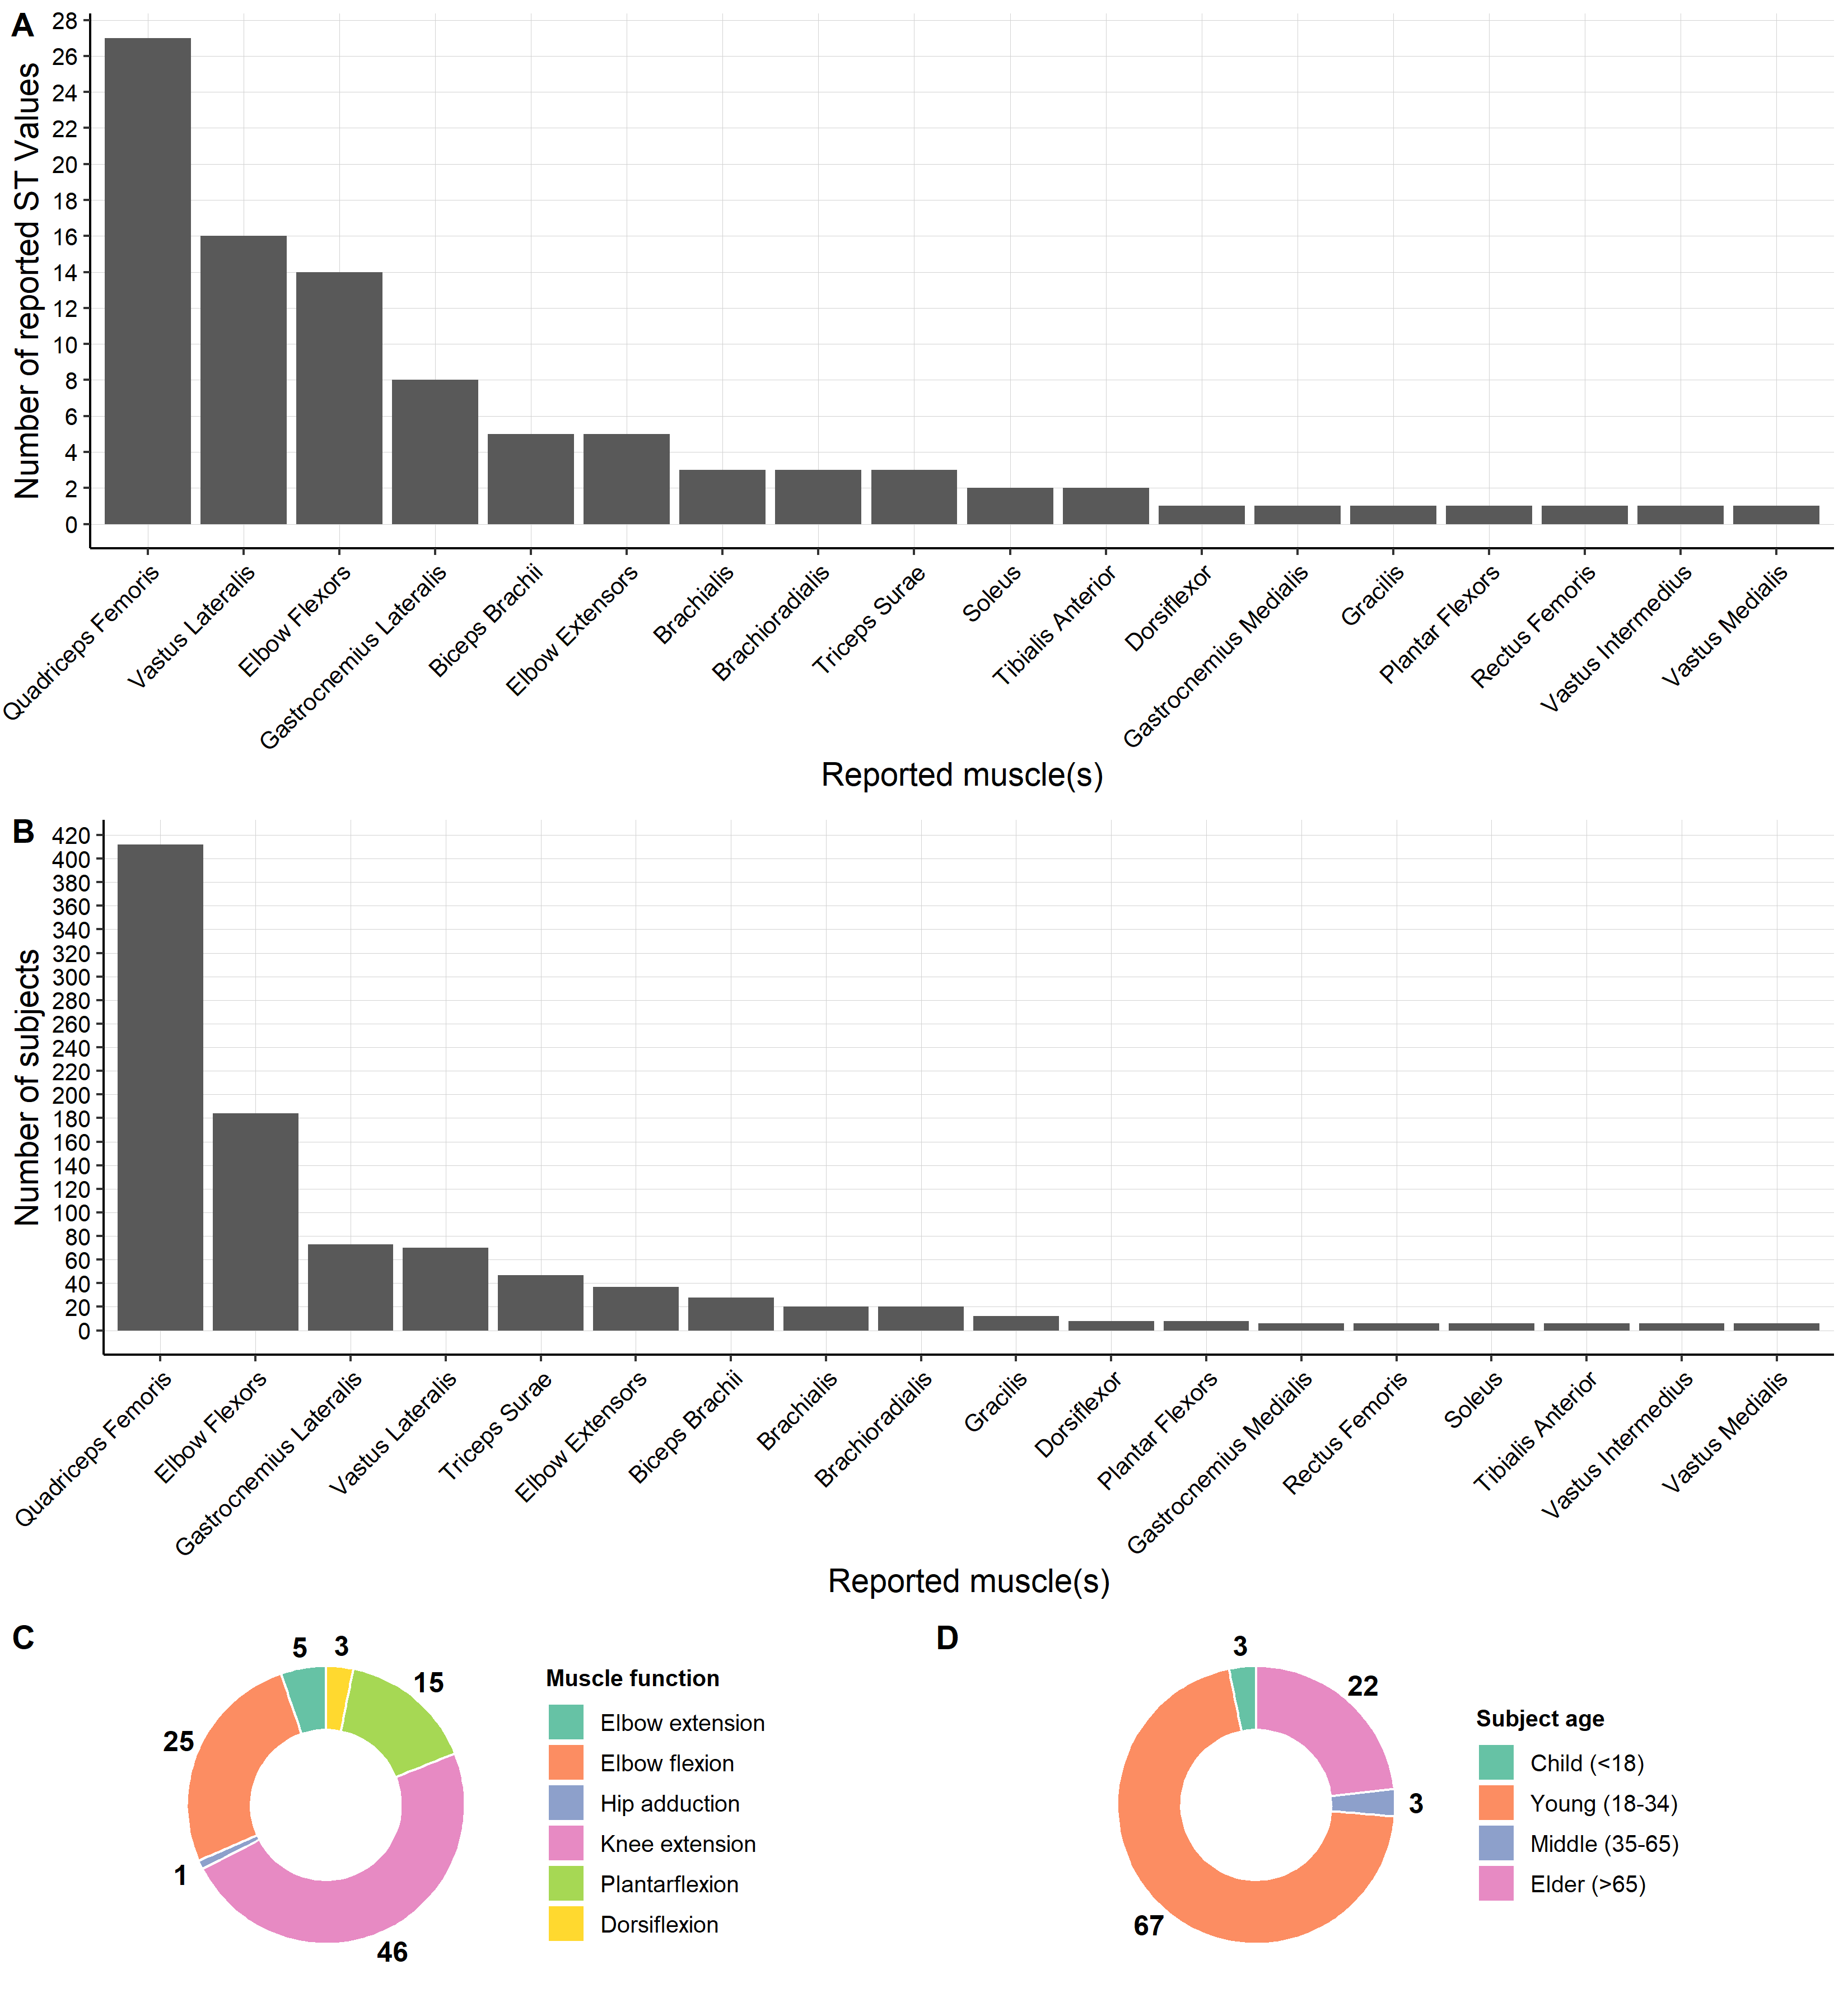

**Figure 4**. Summary of muscle(s) studied. (A) Number of reported ST value by muscle. (B) Cumulative number of subjects studied per muscle. (C) Muscle functional groups for reported ST values. (C) Age distribution for reported ST value.

**Figure 5.** Distribution of specific tension (N/cm²) values for each muscle group. Data are grouped by (A) muscle function (B) anatomical location (C) fiber type composition and (D) training status. Panels B and D display P-values indicating significant differences between groups. In studies assessing the impact of training on specific tension, the control group is considered part of the normal group, while the trained and untrained groups represent the experimental group before and after training. The table above shows all muscles tested along with their corresponding groups. *Muscle fiber type percentages from Tirrell et al. (17).

**Figure 6.** Specific tension values reported by each study. (A) Reported ST values for each included study in chronological order. (B) Median ST value for all included studies shown in Fig. 6A. Multiple ST values are reported for studies that report values for both control and experimental groups before and after training.

**Table 1** Evaluation of specific tension methodology across included studies and their assigned score (based on Figure 1). Abbreviations: ACSA - Anatomical Cross-Sectional Area, CT - Computed Tomography, EMG - Electromyography, ITT - Interpolated Twitch Technique, MA - Moment Arm, MRI - Magnetic Resonance Imaging, MVC - Maximum Voluntary Contraction, PCSA - Physiological Cross-Sectional Area, TQ - Torque, US - Ultrasound.

|  |  |  |  |  |  |  |  |  |  |  |
| --- | --- | --- | --- | --- | --- | --- | --- | --- | --- | --- |
| Summary of methods | Authors | | Year | | Muscle (s) | | ST value  (N/cm2) | | Score | |
| • Torque not used in calculation • Tendon force measured via stimulation of the motor nerve. • Moment arm not used in calculation • Muscle volume estimated by 3D photogrammetric reconstruction • Fascicle length calculated from measured muscle length, active force-length curve parameter FWHM and literature FWHM-optimal fiber length relationship • Pennation angle taken from literature • PCSA= (Muscle vol/Fiber length)*cos(pennation angle) | Binder-Markey et al. (17) | | 2023 | | Gracilis | | 17.1 | | 27 | |
| • MVC torque measured using ITT to correct for muscle activation and EMG to correct for antagonist activation • Tendon force= TQ/MA • Moment arm measured (MRI) during rest and not corresponding to max. torque joint angle • Muscle volume estimated by summation of MRI axial images • Fascicle length measured (US) during max. torque trial • Pennation angle measured during max. torque trial • PCSA= (Muscle vol/Fiber length)*cos(pennation angle) | Erskine et al. (7) | | 2011 | | Quadriceps Femoris | | 26.5 | | 24 | |
| O'Brien et al. (3) | | 2010 | | Quadriceps Femoris | | 55.0 | | 24 | |
| • MVC torque measured using ITT to correct for muscle activation and EMG to correct for antagonist activation • Tendon force= TQ/MA • Moment arm measured (MRI) during rest and corrected using literature values to reflect MVC conditions and max. torque joint angle  • Muscle volume estimated by summation of MRI axial images • Fascicle length measured (US) during max. torque trial • Pennation angle measured during max. torque trial • PCSA= (Muscle vol/Fiber length)*cos(pennation angle) | Erskine et al. (27)  Erskine et al. (9) | | 2010 2009 | | Quadriceps Femoris Quadriceps Femoris | | 29.5  30.3 | | 24 | |
| • Max. torque measured (percutaneous electrical stimulation) and EMG correction for antagonist activation • Tendon force= TQ/MA • Moment arm measured (MRI) during rest and corresponding to max. torque joint angle • Muscle volume estimated by summation of MRI axial images • Fascicle length measured (US) during max. torque trial • Pennation angle measured during max. torque trial • PCSA= (Muscle vol/Fiber length)*cos(pennation angle) | Maganaris et al. (16) | | 2001 | | Soleus  Tibialis Anterior | | 15.0  15.5 | | 23 | |
| • MVC torque measured using ITT to correct for muscle activation and EMG to correct for antagonist activation • Component tendon force calculated using relative PCSA • Moment arm measured (US) during torque trials at max. torque joint angle • Muscle volume estimated by summation of MRI axial images • Fascicle length measured (US) during max. torque trial • Pennation angle measured during max. torque trial • PCSA= (Muscle vol/Fiber length)*cos(pennation angle) | Kubo et al. (28) | | 2006 | | Vastus Lateralis | | 23.1 | | 22 | |
| • MVC torque measured with EMG to correct for antagonist activation • Tendon force= TQ/MA • Moment arm measured (MRI) during rest and corrected using literature values to correspond to max. torque joint angle  • Muscle volume estimated by summation of MRI axial images • Fascicle length measured (US) during rest • Pennation angle measured during max. torque trial • PCSA= (Muscle vol/Fiber length)*cos(pennation angle) | Maden-Wilkinson et al. (29) | | 2020 | | Quadriceps Femoris | | 33.3 | | 21 | |
| • MVC torque measured using ITT to correct for muscle activation • Tendon force= TQ/MA • Moment arm measured (MRI) during rest and corrected using literature values to reflect MVC conditions and max. torque joint angle  • Muscle volume estimated by summation of MRI axial images • Fascicle length measured (US) during max. torque trial • Pennation angle taken from literature • PCSA= (Muscle vol/Fiber length)*cos(pennation angle) | McPhee et al. (12) | | 2018 | | Quadriceps Femoris | | 29.0 | | 21 | |
| • MVC torque measured using ITT to correct for muscle activation and EMG to correct for antagonist activation • Component tendon force calculated using relative PCSA • Moment arm measured (MRI) during rest and not corresponding to max. torque joint angle • Muscle volume estimated by summation of MRI axial images • Fascicle length measured (US) during max. torque trial • Pennation angle measured during max. torque trial • PCSA= (Muscle vol/Fiber length)*cos(pennation angle) | Morse et al. (5)  Morse et al .(23) | | 2007 2005 | | Gastrocnemius Lateralis Gastrocnemius Lateralis | | 8.9  13.1 | | 21 | |
| • MVC torque measured using ITT to correct for muscle activation and EMG to correct for antagonist activation • Component tendon force calculated using relative PCSA • Moment arm measured (MRI) during rest and corrected using literature values to reflect MVC conditions and max. torque joint angle  • Muscle volume estimated by summation of MRI axial images • Fascicle length measured (US) during rest • Pennation angle measured during max. torque trial • PCSA= (Muscle vol/Fiber length)*cos(pennation angle) | Valamatos et al. (30) | | 2018 | | Vastus Lateralis | | 31.8 | | 20 | |
| • MVC torque measured using ITT to correct for muscle activation and EMG to correct for antagonist activation • Component tendon force calculated using relative contribution taken from literature • Moment arm measured (MRI) during rest and corrected using literature values to correspond to max. torque joint angle  • Muscle volume estimated by summation of MRI axial images • Fascicle length measured (US) during rest • Pennation angle measured during max. torque trial • PCSA= (Muscle vol/Fiber length)*cos(pennation angle) | Reeves et al. (4) | | 2004 | | Vastus Lateralis | | 27.0 | | 19 | |
| • MVC torque measured with EMG to correct for antagonist activation • Component tendon force calculated using relative PCSA • Moment arm measured (MRI) during rest and corrected using literature values to correspond to max. torque joint angle  • Muscle volume estimated by summation of MRI axial images • Fascicle length measured (US) during max. torque trial • Pennation angle measured during max. torque trial • PCSA= (Muscle vol/Fiber length)*cos(pennation angle) | Morse et al. (2) | | 2008 | | Gastrocnemius Lateralis | | 13.1 | | 19 | |
| • Max. torque measured (surface neuromuscular electrical stimulation) • Tendon force= TQ/MA • Moment arm corresponding to a value taken from literature at the max. torque joint angle. This value was corrected for cadaver shrinkage and changes during MVC.  • Muscle volume estimated by summation of MRI axial images for activated ACSA • Fascicle length calculated from measured muscle length and literature ratio • Pennation angle taken from literature • PCSA= (Muscle vol/Fiber length)*cos(pennation angle) | Gorgey et al. (20) | | 2006 | | Quadriceps Femoris | | 25 | | 19 | |
| • MVC torque measured using ITT to correct for muscle activation and EMG to correct for antagonist activation • Tendon force= TQ/MA • Moment arm measured (MRI) during rest and not corresponding to max. torque joint angle • Muscle volume estimated (MRI) from max. ACSA and literature regression relationship • Fascicle length measured (US) during max. torque trial in a representative muscle (Vastus Lateralis) • Pennation angle measured (US) during max. torque trial in a representative muscle (Vastus Lateralis) • PCSA= (Muscle vol/Fiber length)*cos(pennation angle) | Erskine et al.( 7) | | 2011 | | Quadriceps Femoris | | 25.9 | | 18 | |
| • MVC torque measured using ITT to correct for muscle activation and EMG to correct for antagonist activation • Tendon force= TQ/MA • Moment arm measured (MRI) during rest and corrected using literature values to reflect MVC conditions and max. torque joint angle  • Muscle volume estimated (MRI) from max. ACSA and literature regression relationship • Fascicle length measured (US) during max. torque trial in a representative muscle (Vastus Lateralis) • Pennation angle measured (US) during max. torque trial in a representative muscle (Vastus Lateralis) • PCSA= (Muscle vol/Fiber length)*cos(pennation angle) | Erskine et al. (6) Erskine et al. (9) | | 2010 2009 | | Quadriceps Femoris Quadriceps Femoris | | 29.1  25.6 | | 18 | |
| • MVC torque measured • Tendon force= TQ/MA • Moment arm measured (MRI) during rest and corresponding to max. torque joint angle • Muscle volume estimated by summation of MRI axial images • Fascicle length calculated from measured muscle length and literature ratio • Pennation angle taken from literature • PCSA= (Muscle vol/Fiber length)*cos(pennation angle) | Kawakami et al. (14) | | 1994 | | Elbow Extensors | | 65.4 | | 18 | |
| • MVC torque measured using ITT to correct for muscle activation and EMG to correct for antagonist activation • Component tendon force calculated using relative contribution taken from literature • Moment arm measured (X-ray) at max. torque joint angle during rest • Muscle volume estimated (US) from max. ACSA and literature regression relationship • Fascicle length measured (US) during max. torque trial • Pennation angle measured during max. torque trial • PCSA= (Muscle vol/Fiber length)*cos(pennation angle) | Sims et al. (19) | | 2018 | | Vastus Lateralis | | 23.6 | | 17 | |
| • MVC torque measured • Tendon force= TQ/MA • Moment arm measured (MRI) during rest and not corresponding to max. torque joint angle • Muscle volume estimated by summation of MRI axial images • Fascicle length calculated from measured muscle length and literature ratio • Pennation angle taken from literature • PCSA= (Muscle vol/Fiber length)*cos(pennation angle) | Fukunaga et al. (10) | | 1996 | | Triceps Surae  Plantar Flexors  Dorsiflexors | | 10.8  8.0  24.5 | | 17 | |
| • MVC torque measured • Tendon force= TQ/MA • Moment arm measured (MRI) during rest and corresponding to max. torque joint angle • Muscle volume estimated by summation of MRI axial images • Fascicle length calculated from measured muscle length and literature ratio • Pennation angle not used in calculation • PCSA= Muscle vol/Fiber length | Kawakami et al. (14) | | 1994 | | Elbow Flexors | | 72.7 | | 17 | |
| • MVC torque measured using ITT to correct for muscle activation and EMG to correct for antagonist activation • Tendon force approximated from external limb force • Moment arm not used in calculation • Muscle volume estimated by summation of MRI axial images • Fascicle length calculated from measured muscle length and literature ratio • Pennation angle taken from literature • PCSA= (Muscle vol/Fiber length)*cos(pennation angle) | Klein et al. (24) | | 2001 | | Elbow Extensors | | 5.5 | | 16 | |
| • MVC torque measured • Component tendon force calculated using relative PCSA x MA • Moment arm measured (MRI) during rest and corrected using literature values to correspond to max. torque joint angle  • Muscle volume estimated by summation of MRI axial images • Fascicle length calculated from measured muscle length and literature ratio • Pennation angle taken from literature • PCSA= (Muscle vol/Fiber length)*cos(pennation angle) | Marchetta et al.( 11) | | 2012 | | Biceps Brachii Brachialis Brachioradialis | | 53.4  56.5  53.5 | | 15 | |
| • MVC torque measured with gravity correction • Tendon force= TQ/MA • Moment arm measured (MRI) during rest and not corresponding to max. torque joint angle • Muscle volume estimated by summation of MRI axial images • Fascicle length taken from literature • Pennation angle taken from literature • PCSA= (Muscle vol/Fiber length)*cos(pennation angle) | Maganaris et al. (16) | | 2001 | | Soleus  Tibialis Anterior | | 10.4  65.8 | | 15 | |
| • MVC torque measured using ITT to correct for muscle activation and EMG to correct for antagonist activation • Tendon force approximated from external limb force • Moment arm not used in calculation • Muscle volume estimated by summation of MRI axial images • Fascicle length calculated from measured muscle length and literature ratio • Pennation angle not used in calculation • PCSA= Muscle vol/Fiber length | Klein et al. (24) | | 2001 | | Elbow Flexors | | 16.5 | | 15 | |
| • Torque not used in calculation • Tendon force approximated from external limb force • Moment arm not used in calculation • Muscle volume estimated by summation of MRI axial images • Fascicle length measured (US) during max. torque trial • Pennation angle measured during max. torque trial • PCSA= (Muscle vol/Fiber length)*cos(pennation angle) | Narici et al. (21) | | 1996 | | Gastrocnemius Medialis | | 13.3 | | 15 | |
| • MVC torque measured • Component tendon force calculated using relative PCSA x MA • Moment arm measured (MRI) during rest and corresponding to max. torque joint angle • Muscle volume estimated by summation of MRI axial images • Fascicle length calculated from measured muscle length and literature ratio • Pennation angle not used in calculation • PCSA= Muscle vol/Fiber length | Kawakami et al. (14) | | 1994 | | Biceps Brachii Brachialis Brachioradialis | | 72.3  72.3  71.9 | | 15 | |
| • Torque not used in calculation • Tendon force approximated from external limb force • Moment arm corresponding to a value taken from literature at the max. torque joint angle • Muscle volume estimated by summation of MRI axial images • Fascicle length measured (MRI) during rest • Pennation angle measured during max. torque trial • PCSA= (Muscle vol/muscle thickness)*sin(pennation angle) | Narici et al. (18) | | 1992 | | Vastus Lateralis  Vastus Intermedius  Vastus Medialis  Rectus Femoris | | 23.7  24.1  27.9  24.3 | | 14 | |
| • Torque not used in calculation • Tendon force approximated from external limb force • Moment arm not used in calculation • Muscle volume estimated by summation of MRI axial images • Fascicle length calculated from measured muscle length and literature ratio • Pennation angle taken from literature • PCSA= (Muscle vol/Fiber length)*cos(pennation angle) | Bamman et al. (13) | | 2000 | | Triceps Surae | | 1.97 | | 12 | |
| • MVC torque measured • Component tendon force calculated using relative contribution taken from literature • Moment arm corresponding to a value taken from literature at the max. torque joint angle • Muscle volume not used in calculation • Fascicle length not used in calculation • Pennation angle not used in calculation • ACSA=Max. ACSA measured (CT) during rest and corrected using literature data to correspond to ACSA during max. Torque | | Klitgaard et al. (26) | | 1990 | | Elbow Flexors | | 65.4 | | 12 | |
| Nygaard et al. (22) | | 1983 | | Biceps Brachii | | 35.6 | | 12 | |
| • MVC torque measured with gravity correction • Component tendon force calculated using relative contribution taken from literature • Moment arm corresponding to a value taken from literature at the max. torque joint angle • Muscle volume estimated by summation of MRI axial images • Fascicle length taken from literature • Pennation angle measured during max. torque trial • PCSA= (Muscle vol/Fiber length)*cos(pennation angle) | Aagaard et al .(31) | | 2001 | | Quadriceps Femoris | | 42.6 | | 10 | |
| • MVC torque measured • Component tendon force calculated using relative PCSA x MA • Moment arm corresponding to a value taken from literature at the max. torque joint angle • Muscle volume not used in calculation • Fascicle length not used in calculation • Pennation angle not used in calculation • ACSA=Max. ACSA measured (CT) during rest | Dowling et al. (32) | | 1994 | | Elbow Flexors | | 69 | | 10 | |
| • MVC torque measured • Tendon force approximated from external limb force • Limb length used as moment arm • Muscle volume not used in calculation • Fascicle length not used in calculation • Pennation angle not used in calculation • ACSA=Max. ACSA measured (MRI) | Akagi et al. (25) | | 2009 | | Elbow Flexors | | 14.7 | | 9 | |
| Summary of methods | | Authors | | Year | | Muscle (s) | ST value  (N/cm2) | Score | |
| • Torque not used in calculation • Tendon force measured via stimulation of the motor nerve. • Moment arm not used in calculation • Muscle volume estimated by 3D photogrammetric reconstruction • Fascicle length calculated from measured muscle length, active force-length curve parameter FWHM and literature FWHM-optimal fiber length relationship • Pennation angle taken from literature • PCSA= (Muscle vol/Fiber length)*cos(pennation angle) | | Binder-Markey et al. (18) | | 2023 | | Gracilis | 17.1 | 27 | |
| • MVC torque measured using ITT to correct for muscle activation and EMG to correct for antagonist activation • Tendon force= TQ/MA • Moment arm measured (MRI) during rest and not corresponding to max. torque joint angle • Muscle volume estimated by summation of MRI axial images • Fascicle length measured (US) during max. torque trial • Pennation angle measured during max. torque trial • PCSA= (Muscle vol/Fiber length)*cos(pennation angle) | | Erskine et al. (7) | | 2011 | | Quadriceps Femoris | 26.5 | 24 | |
| O'Brien et al. (3) | | 2010 | | Quadriceps Femoris | 55.0 | 24 | |
| • MVC torque measured using ITT to correct for muscle activation and EMG to correct for antagonist activation • Tendon force= TQ/MA • Moment arm measured (MRI) during rest and corrected using literature values to reflect MVC conditions and max. torque joint angle  • Muscle volume estimated by summation of MRI axial images • Fascicle length measured (US) during max. torque trial • Pennation angle measured during max. torque trial • PCSA= (Muscle vol/Fiber length)*cos(pennation angle) | | Erskine et al. (28)  Erskine et al. (9) | | 2010 2009 | | Quadriceps Femoris Quadriceps Femoris | 29.5  30.3 | 24 | |
| • Max. torque measured (percutaneous electrical stimulation) and EMG correction for antagonist activation • Tendon force= TQ/MA • Moment arm measured (MRI) during rest and corresponding to max. torque joint angle • Muscle volume estimated by summation of MRI axial images • Fascicle length measured (US) during max. torque trial • Pennation angle measured during max. torque trial • PCSA= (Muscle vol/Fiber length)*cos(pennation angle) | | Maganaris et al. (16) | | 2001 | | Soleus  Tibialis Anterior | 15.0  15.5 | 23 | |
| • MVC torque measured using ITT to correct for muscle activation and EMG to correct for antagonist activation • Component tendon force calculated using relative PCSA • Moment arm measured (US) during torque trials at max. torque joint angle • Muscle volume estimated by summation of MRI axial images • Fascicle length measured (US) during max. torque trial • Pennation angle measured during max. torque trial • PCSA= (Muscle vol/Fiber length)*cos(pennation angle) | | Kubo et al. (29) | | 2006 | | Vastus Lateralis | 23.1 | 22 | |
| • MVC torque measured with EMG to correct for antagonist activation • Tendon force= TQ/MA • Moment arm measured (MRI) during rest and corrected using literature values to correspond to max. torque joint angle  • Muscle volume estimated by summation of MRI axial images • Fascicle length measured (US) during rest • Pennation angle measured during max. torque trial • PCSA= (Muscle vol/Fiber length)*cos(pennation angle) | | Maden-Wilkinson et al. (30) | | 2020 | | Quadriceps Femoris | 33.3 | 21 | |
| • MVC torque measured using ITT to correct for muscle activation • Tendon force= TQ/MA • Moment arm measured (MRI) during rest and corrected using literature values to reflect MVC conditions and max. torque joint angle  • Muscle volume estimated by summation of MRI axial images • Fascicle length measured (US) during max. torque trial • Pennation angle taken from literature • PCSA= (Muscle vol/Fiber length)*cos(pennation angle) | | McPhee et al. (12) | | 2018 | | Quadriceps Femoris | 29.0 | 21 | |
| • MVC torque measured using ITT to correct for muscle activation and EMG to correct for antagonist activation • Component tendon force calculated using relative PCSA • Moment arm measured (MRI) during rest and not corresponding to max. torque joint angle • Muscle volume estimated by summation of MRI axial images • Fascicle length measured (US) during max. torque trial • Pennation angle measured during max. torque trial • PCSA= (Muscle vol/Fiber length)*cos(pennation angle) | | Morse et al. (5)  Morse et al .(24) | | 2007 2005 | | Gastrocnemius Lateralis Gastrocnemius Lateralis | 8.9  13.1 | 21 | |
| • MVC torque measured using ITT to correct for muscle activation and EMG to correct for antagonist activation • Component tendon force calculated using relative PCSA • Moment arm measured (MRI) during rest and corrected using literature values to reflect MVC conditions and max. torque joint angle  • Muscle volume estimated by summation of MRI axial images • Fascicle length measured (US) during rest • Pennation angle measured during max. torque trial • PCSA= (Muscle vol/Fiber length)*cos(pennation angle) | | Valamatos et al. (31) | | 2018 | | Vastus Lateralis | 31.8 | 20 | |
| • MVC torque measured using ITT to correct for muscle activation and EMG to correct for antagonist activation • Component tendon force calculated using relative contribution taken from literature • Moment arm measured (MRI) during rest and corrected using literature values to correspond to max. torque joint angle  • Muscle volume estimated by summation of MRI axial images • Fascicle length measured (US) during rest • Pennation angle measured during max. torque trial • PCSA= (Muscle vol/Fiber length)*cos(pennation angle) | | Reeves et al. (4) | | 2004 | | Vastus Lateralis | 27.0 | 19 | |
| • MVC torque measured with EMG to correct for antagonist activation • Component tendon force calculated using relative PCSA • Moment arm measured (MRI) during rest and corrected using literature values to correspond to max. torque joint angle  • Muscle volume estimated by summation of MRI axial images • Fascicle length measured (US) during max. torque trial • Pennation angle measured during max. torque trial • PCSA= (Muscle vol/Fiber length)*cos(pennation angle) | | Morse et al. (2) | | 2008 | | Gastrocnemius Lateralis | 13.1 | 19 | |
| • Max. torque measured (surface neuromuscular electrical stimulation) • Tendon force= TQ/MA • Moment arm corresponding to a value taken from literature at the max. torque joint angle. This value was corrected for cadaver shrinkage and changes during MVC.  • Muscle volume estimated by summation of MRI axial images for activated ACSA • Fascicle length calculated from measured muscle length and literature ratio • Pennation angle taken from literature • PCSA= (Muscle vol/Fiber length)*cos(pennation angle) | | Gorgey et al. (21) | | 2006 | | Quadriceps Femoris | 25 | 19 | |
| • MVC torque measured using ITT to correct for muscle activation and EMG to correct for antagonist activation • Tendon force= TQ/MA • Moment arm measured (MRI) during rest and not corresponding to max. torque joint angle • Muscle volume estimated (MRI) from max. ACSA and literature regression relationship • Fascicle length measured (US) during max. torque trial in a representative muscle (Vastus Lateralis) • Pennation angle measured (US) during max. torque trial in a representative muscle (Vastus Lateralis) • PCSA= (Muscle vol/Fiber length)*cos(pennation angle) | | Erskine et al.( 7) | | 2011 | | Quadriceps Femoris | 25.9 | 18 | |
| • MVC torque measured using ITT to correct for muscle activation and EMG to correct for antagonist activation • Tendon force= TQ/MA • Moment arm measured (MRI) during rest and corrected using literature values to reflect MVC conditions and max. torque joint angle  • Muscle volume estimated (MRI) from max. ACSA and literature regression relationship • Fascicle length measured (US) during max. torque trial in a representative muscle (Vastus Lateralis) • Pennation angle measured (US) during max. torque trial in a representative muscle (Vastus Lateralis) • PCSA= (Muscle vol/Fiber length)*cos(pennation angle) | | Erskine et al. (6) Erskine et al. (9) | | 2010 2009 | | Quadriceps Femoris Quadriceps Femoris | 29.1  25.6 | 18 | |
| • MVC torque measured • Tendon force= TQ/MA • Moment arm measured (MRI) during rest and corresponding to max. torque joint angle • Muscle volume estimated by summation of MRI axial images • Fascicle length calculated from measured muscle length and literature ratio • Pennation angle taken from literature • PCSA= (Muscle vol/Fiber length)*cos(pennation angle) | | Kawakami et al. (14) | | 1994 | | Elbow Extensors | 65.4 | 18 | |
| • MVC torque measured using ITT to correct for muscle activation and EMG to correct for antagonist activation • Component tendon force calculated using relative contribution taken from literature • Moment arm measured (X-ray) at max. torque joint angle during rest • Muscle volume estimated (US) from max. ACSA and literature regression relationship • Fascicle length measured (US) during max. torque trial • Pennation angle measured during max. torque trial • PCSA= (Muscle vol/Fiber length)*cos(pennation angle) | | Sims et al. (20) | | 2018 | | Vastus Lateralis | 23.6 | 17 | |
| • MVC torque measured • Tendon force= TQ/MA • Moment arm measured (MRI) during rest and not corresponding to max. torque joint angle • Muscle volume estimated by summation of MRI axial images • Fascicle length calculated from measured muscle length and literature ratio • Pennation angle taken from literature • PCSA= (Muscle vol/Fiber length)*cos(pennation angle) | | Fukunaga et al. (10) | | 1996 | | Triceps Surae  Plantar Flexors  Dorsiflexors | 10.8  8.0  24.5 | 17 | |
| • MVC torque measured • Tendon force= TQ/MA • Moment arm measured (MRI) during rest and corresponding to max. torque joint angle • Muscle volume estimated by summation of MRI axial images • Fascicle length calculated from measured muscle length and literature ratio • Pennation angle not used in calculation • PCSA= Muscle vol/Fiber length | | Kawakami et al. (14) | | 1994 | | Elbow Flexors | 72.7 | 17 | |
| • MVC torque measured using ITT to correct for muscle activation and EMG to correct for antagonist activation • Tendon force approximated from external limb force • Moment arm not used in calculation • Muscle volume estimated by summation of MRI axial images • Fascicle length calculated from measured muscle length and literature ratio • Pennation angle taken from literature • PCSA= (Muscle vol/Fiber length)*cos(pennation angle) | | Klein et al. (25) | | 2001 | | Elbow Extensors | 5.5 | 16 | |
| • MVC torque measured • Component tendon force calculated using relative PCSA x MA • Moment arm measured (MRI) during rest and corrected using literature values to correspond to max. torque joint angle  • Muscle volume estimated by summation of MRI axial images • Fascicle length calculated from measured muscle length and literature ratio • Pennation angle taken from literature • PCSA= (Muscle vol/Fiber length)*cos(pennation angle) | | Marchetta et al.( 11) | | 2012 | | Biceps Brachii Brachialis Brachioradialis | 53.4  56.5  53.5 | 15 | |
| • MVC torque measured with gravity correction • Tendon force= TQ/MA • Moment arm measured (MRI) during rest and not corresponding to max. torque joint angle • Muscle volume estimated by summation of MRI axial images • Fascicle length taken from literature • Pennation angle taken from literature • PCSA= (Muscle vol/Fiber length)*cos(pennation angle) | | Maganaris et al. (16) | | 2001 | | Soleus  Tibialis Anterior | 10.4  65.8 | 15 | |
| • MVC torque measured using ITT to correct for muscle activation and EMG to correct for antagonist activation • Tendon force approximated from external limb force • Moment arm not used in calculation • Muscle volume estimated by summation of MRI axial images • Fascicle length calculated from measured muscle length and literature ratio • Pennation angle not used in calculation • PCSA= Muscle vol/Fiber length | | Klein et al. (25) | | 2001 | | Elbow Flexors | 16.5 | 15 | |
| • Torque not used in calculation • Tendon force approximated from external limb force • Moment arm not used in calculation • Muscle volume estimated by summation of MRI axial images • Fascicle length measured (US) during max. torque trial • Pennation angle measured during max. torque trial • PCSA= (Muscle vol/Fiber length)*cos(pennation angle) | | Narici et al. (22) | | 1996 | | Gastrocnemius Medialis | 13.3 | 15 | |
| • MVC torque measured • Component tendon force calculated using relative PCSA x MA • Moment arm measured (MRI) during rest and corresponding to max. torque joint angle • Muscle volume estimated by summation of MRI axial images • Fascicle length calculated from measured muscle length and literature ratio • Pennation angle not used in calculation • PCSA= Muscle vol/Fiber length | | Kawakami et al. (14) | | 1994 | | Biceps Brachii Brachialis Brachioradialis | 72.3  72.3  71.9 | 15 | |
| • Torque not used in calculation • Tendon force approximated from external limb force • Moment arm corresponding to a value taken from literature at the max. torque joint angle • Muscle volume estimated by summation of MRI axial images • Fascicle length measured (MRI) during rest • Pennation angle measured during max. torque trial • PCSA= (Muscle vol/muscle thickness)*sin(pennation angle) | | Narici et al. (19) | | 1992 | | Vastus Lateralis  Vastus Intermedius  Vastus Medialis  Rectus Femoris | 23.7  24.1  27.9  24.3 | 14 | |
| • Torque not used in calculation • Tendon force approximated from external limb force • Moment arm not used in calculation • Muscle volume estimated by summation of MRI axial images • Fascicle length calculated from measured muscle length and literature ratio • Pennation angle taken from literature • PCSA= (Muscle vol/Fiber length)*cos(pennation angle) | | Bamman et al. (13) | | 2000 | | Triceps Surae | 1.97 | 12 | |
| • MVC torque measured • Component tendon force calculated using relative contribution taken from literature • Moment arm corresponding to a value taken from literature at the max. torque joint angle • Muscle volume not used in calculation • Fascicle length not used in calculation • Pennation angle not used in calculation • ACSA=Max. ACSA measured (CT) during rest and corrected using literature data to correspond to ACSA during max. Torque | | | Klitgaard et al. (27) | | 1990 | | Elbow Flexors | 65.4 | 12 | |
| Nygaard et al. (23) | | 1983 | | Biceps Brachii | 35.6 | 12 | |
| • MVC torque measured with gravity correction • Component tendon force calculated using relative contribution taken from literature • Moment arm corresponding to a value taken from literature at the max. torque joint angle • Muscle volume estimated by summation of MRI axial images • Fascicle length taken from literature • Pennation angle measured during max. torque trial • PCSA= (Muscle vol/Fiber length)*cos(pennation angle) | | Aagaard et al .(32) | | 2001 | | Quadriceps Femoris | 42.6 | 10 | |
| • MVC torque measured • Component tendon force calculated using relative PCSA x MA • Moment arm corresponding to a value taken from literature at the max. torque joint angle • Muscle volume not used in calculation • Fascicle length not used in calculation • Pennation angle not used in calculation • ACSA=Max. ACSA measured (CT) during rest | | Dowling et al. (33) | | 1994 | | Elbow Flexors | 69 | 10 | |
| • MVC torque measured • Tendon force approximated from external limb force • Limb length used as moment arm • Muscle volume not used in calculation • Fascicle length not used in calculation • Pennation angle not used in calculation • ACSA=Max. ACSA measured (MRI) | | Akagi et al. (26) | | 2009 | | Elbow Flexors | 14.7 | 9 | |

**Figure 7.** Scatter plot demonstrating the relationship between ST (N/cm²) and study quality score. The linear regression line is overlaid in red revealing a very slight association between the two.

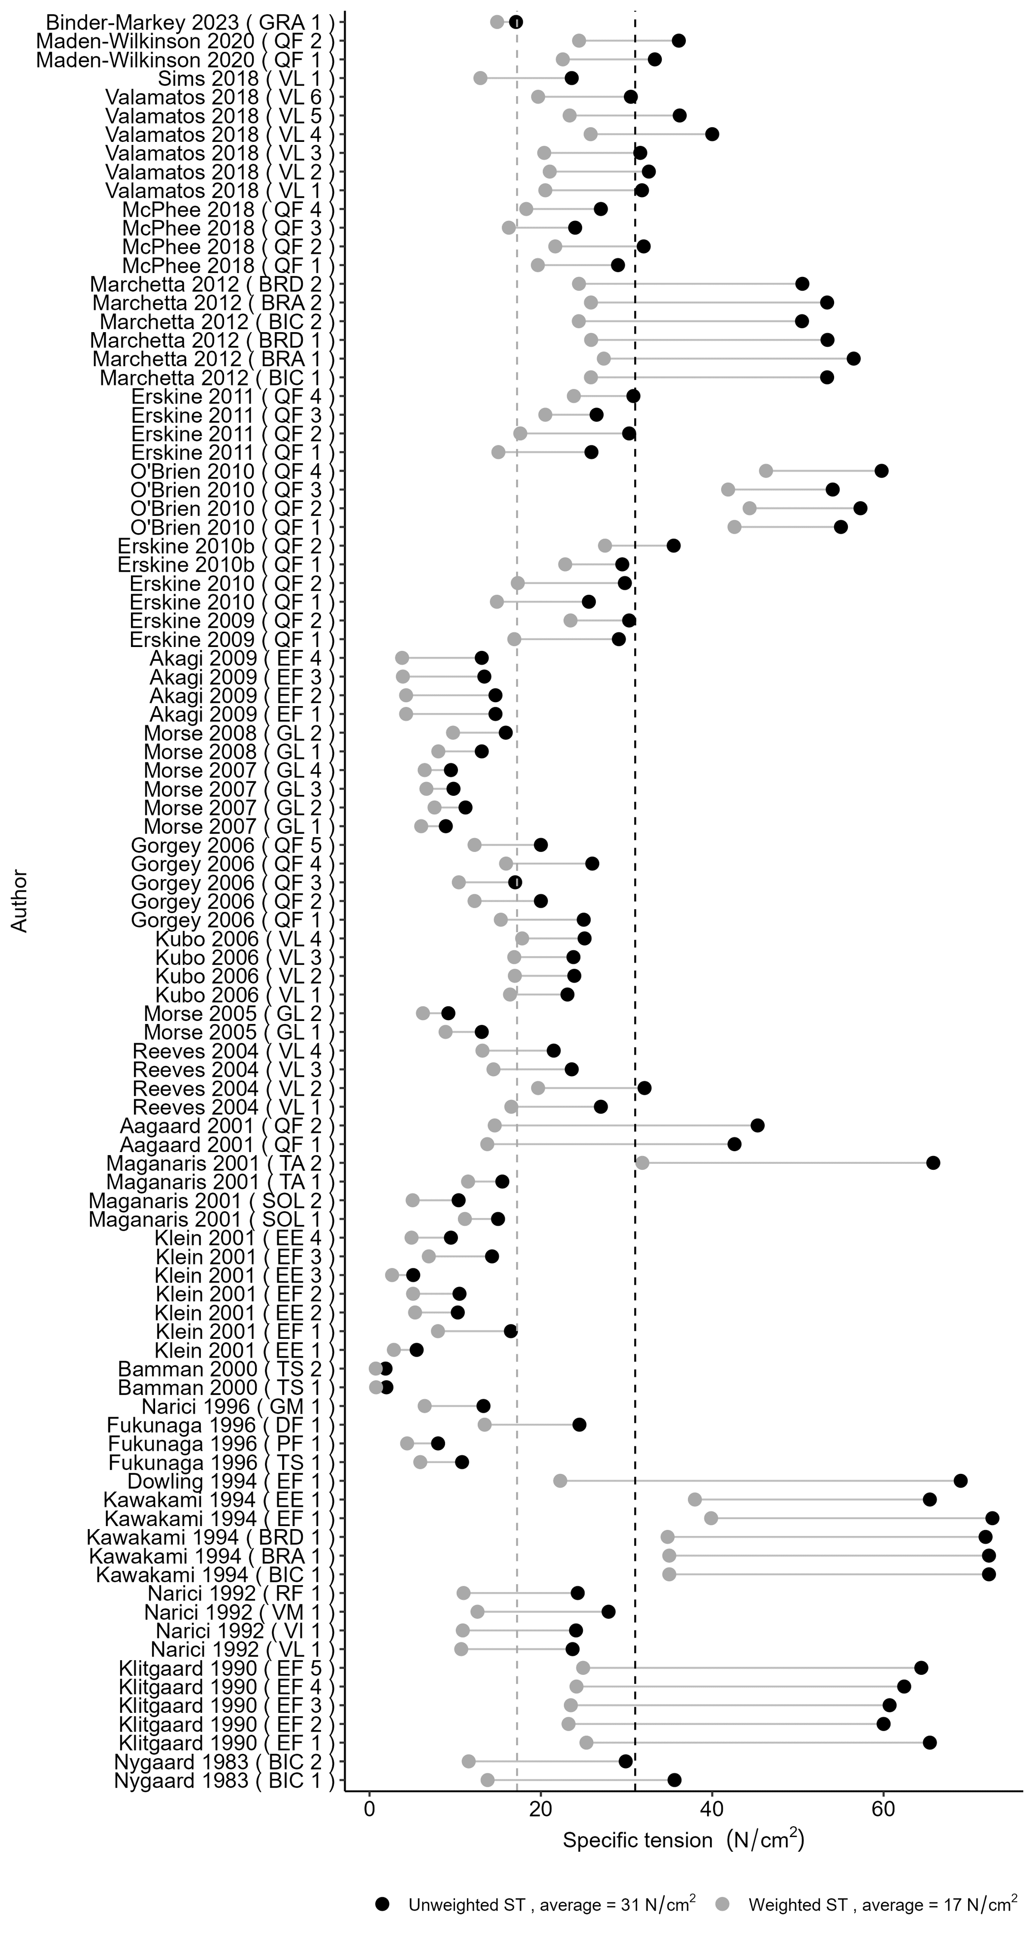

**Figure 8.** Comparison of unweighted (black) and weighted (grey) ST values. Vertical dashed lines show the average value for both groups.